7. Plot of Rose Diagrams
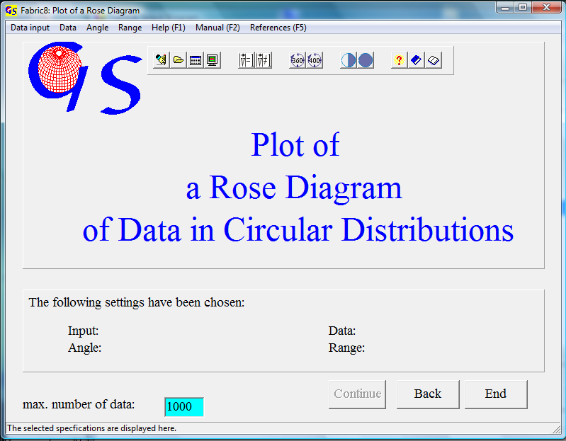
Fig. 1

This program (Fig. 1) allows the graphic presentation of circularly distributed data with various types of rose diagrams.
The data type treated in this program is the same as in program 6, therefore the forms for data input are the same as in program 6.
In the graphic form, you choose the type of diagram in the menu “Rose type” (Fig. 2).

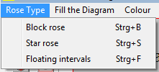 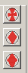 Fig. 2

The three different rose types are:
1. Block rose: The diagram is plotted with sectors.
2. Star rose: The diagram is plotted with the centres of the sectors.
3. Floating intervals: The sectors ara calculated in a "floating" way with overlapping sectors.

In the menu "Fill the Diagram" (Fig. 3) you decide whether the rose diagram shall be filled with a colour or not.
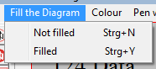  Fig. 3

The Program starts with the parameters already saved in “Fabric.ini”.

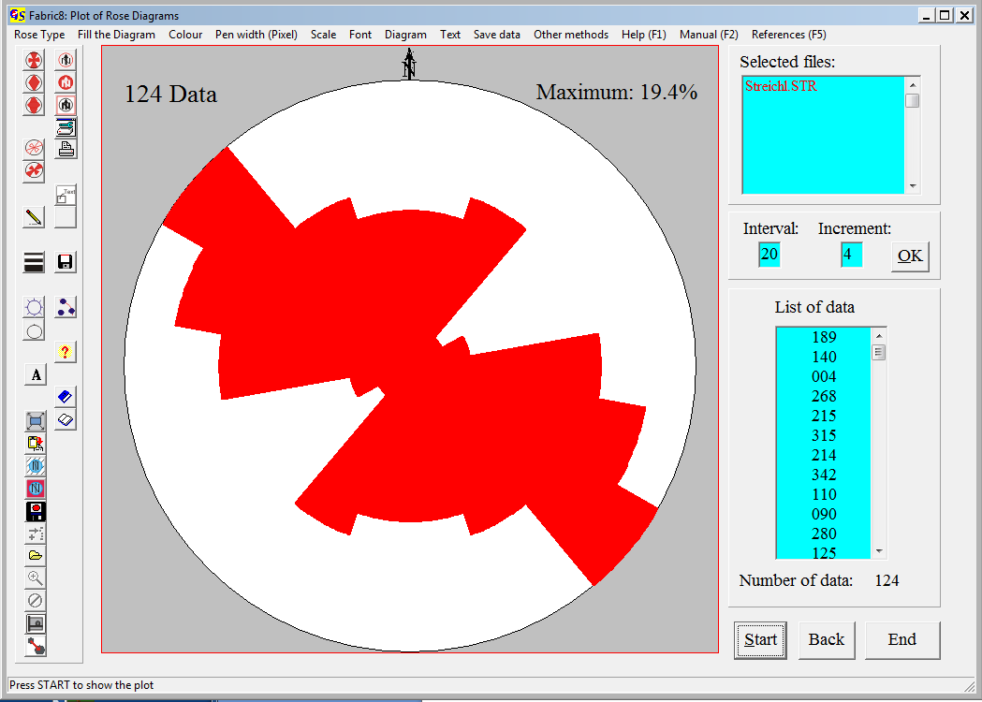
Fig. 4

Write the width of the sectors, with which the diagram shall be plotted, in the field "Interval" (The preset number can be changed). Fig. 4 shows a block rose with an interval of 20°.
The thickness of the contour lines of the roses can be chosen in the menu “Pen width (pixel) which open the scroll list in Fig. 5.

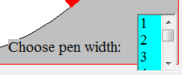
Fig. 5

A scale can be added to the rose diagram in menu “Scale” (Fig. 6)

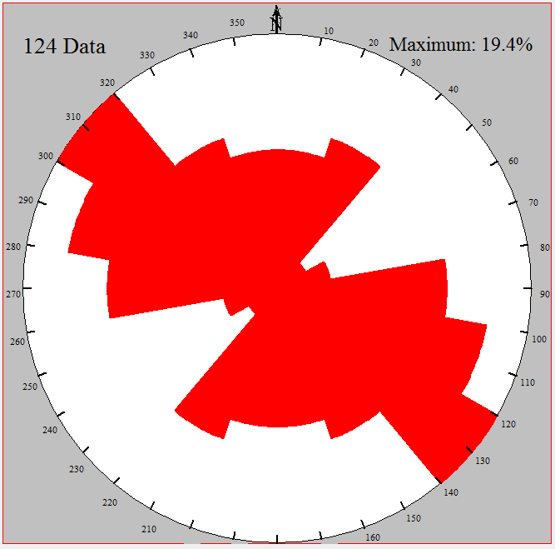Fig. 6

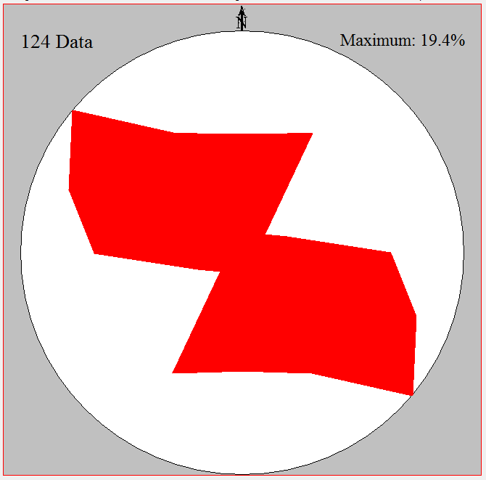
Fig. 7

Fig. 7 shows a star rose, drawn with the same data set.
Fig. 8 is drawn with floating (overlapping) sectors of a width of 20°. For each count of data in a class the sector is rotated by the "Increment" of 5°. This method produces a smooth diagram. The increment should be a divisor of the interval value.

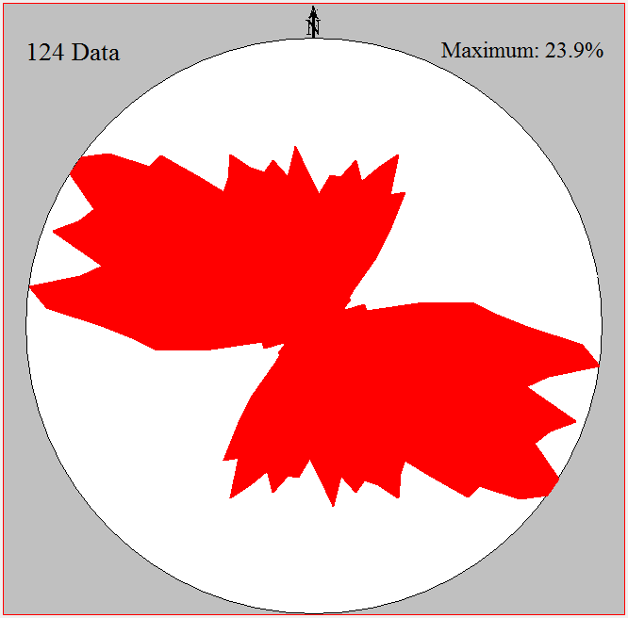 Fig.8

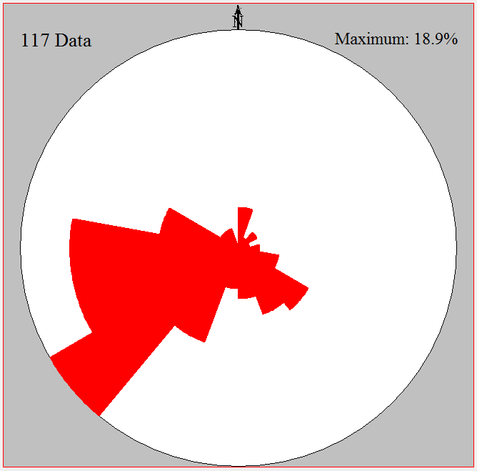
Fig. 9
Fig. 9 show a block rose diagram for polar data with an interval of 20°.

The menus “Diagram”, “Text”, and “Save data” are the same as in Program 3.
With the menu "Other methods" you jump to program 6 (statistical measures of circular data).

